F. Y. B. TECH PROGRAMME
Laboratory Manual (2025-26)

Semester- I

Name of Student: _____________________________

Division/ Batch No.: ___________________________

Roll No.: _____________________________________

SAFETY GUIDELINES

Safety is our biggest concern in this course! You must read and know the section on Safety before starting your first experiment. If you are ever unsure of a procedure, make sure you ask the instructor or the TA.
General Information. A chemistry laboratory is a dangerous place. One must be aware of the dangers and exercise extreme caution at all times. Before beginning work in the laboratory, review the following rules. If you are in violation of any of the following rules, you will be asked to leave the laboratory. Eating, drinking, and smoking are strictly forbidden in the laboratory.
Lab Attire. A lab coat is recommended. Appropriate protective gloves should be worn whenever the potential exists for contact with toxic chemicals/ heat, etc. Shorts and slippers are not safe lab attire since they provide no protection from splashed or spilled materials. Bare feet are absolutely forbidden in the laboratory. To avoid entanglement with laboratory equipment, necklaces and bracelets should not be worn, and long hair should be tied back.
Chemical Spills. Clean up chemical and water spills immediately. If the spill involves dangerous chemicals, inform the instructor or the TA. Water on the floor can cause slips and falls, and should, therefore, be cleaned up as soon as possible.
Check Glassware. Small cracks or "star-cracks" can cause the glassware to break, explode, or implode. Broken glass should be returned over to the instructor or TA immediately.
Working with Chemicals. If you are unfamiliar with the properties, safe handling procedures, or disposal requirements of any chemical, consult with your instructor or TA before you attempt to use it. Dispose of all chemical waste in the appropriate containers that are supplied.
Inappropriate Conduct. Disruptive behavior will lead to your immediate dismissal from the laboratory.
Be Prepared. Be familiar with the task at hand

COMMON LABORATORY GLASSWARES

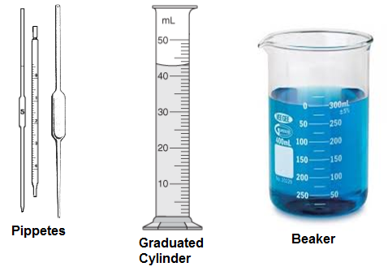
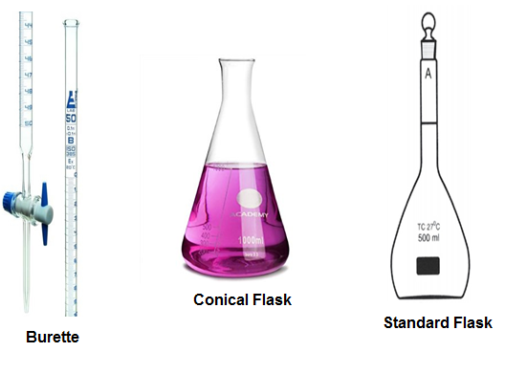
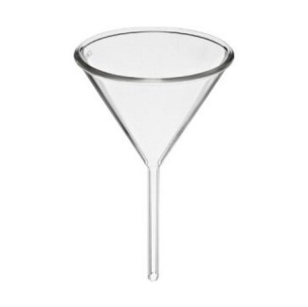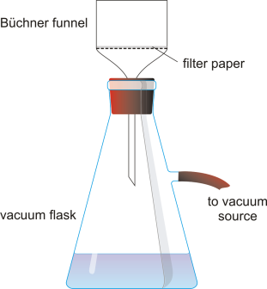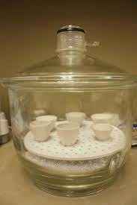
Funnel Filteration Assembly Desicator with crucibles

Table of Contents
S. No. | Experiment | Date of Performance | Page No. | Sign/ Remark
1 | Good laboratory Practices (GLP)
2 | To determine the EMF of cell and predict it’s spontaneity (VLab)
3 | To determine various types of hardness of water using complexometric titration- EDTA method
4 | Green Synthesis of Biodiesel from Vegetable Oil Using Base  Catalysis
5 | Preparation of Benzalacetophenone via Claisen–Schmidt Condensation
6 | Non-Destructive evaluation of corrosion rate in bare rebar/ reinforced concrete
7

Name of Faculty:

Signature of Faculty:

